**Lagrangian interpolate:**

To prove the correctness of the algorithm we used the wolframalpha software:

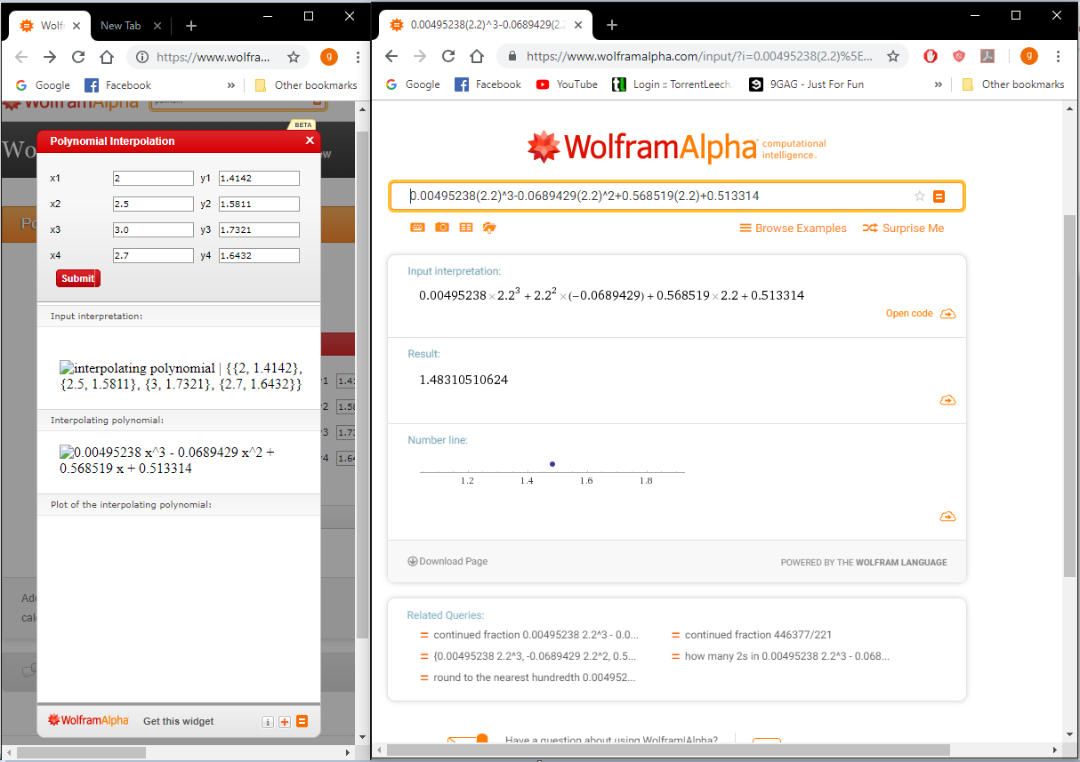

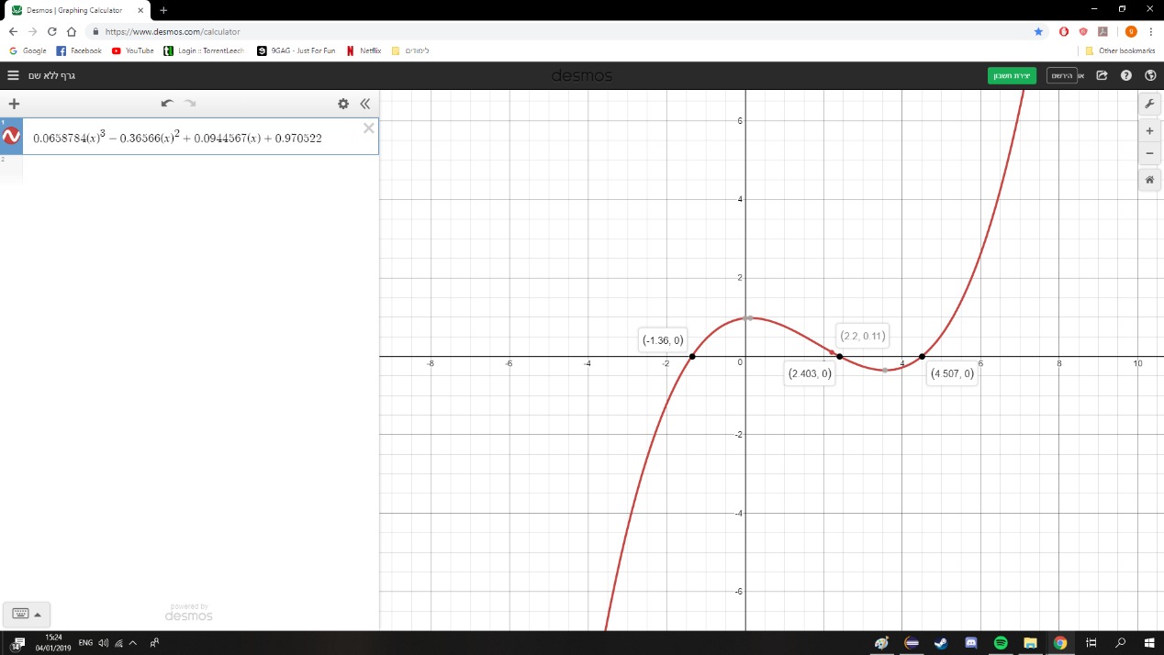

The algorithm in code and its results:

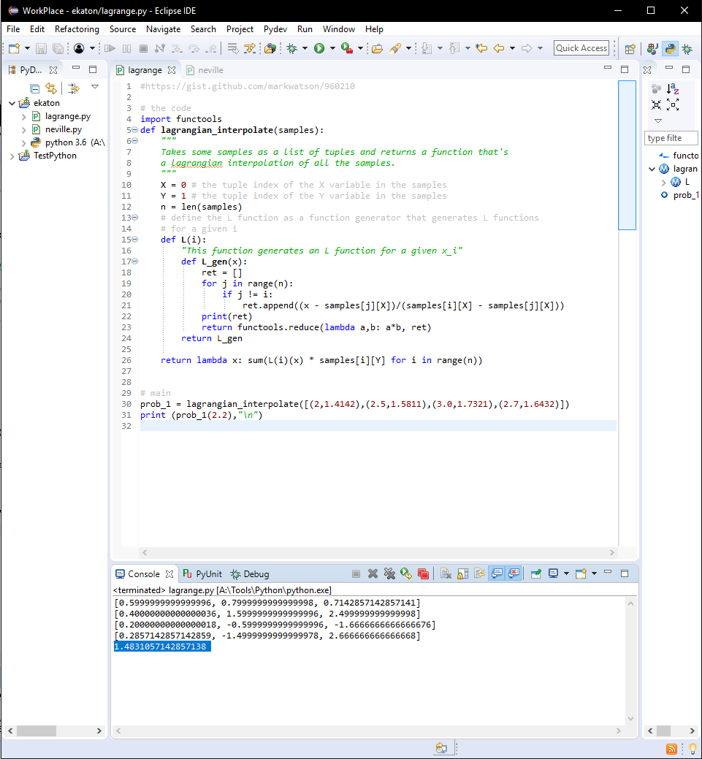

**Lagrangian interpolate error:**

